PROBLEM TREE

This tool has been adapted from:
- Project Cycle Handbook, Tdh, 2012
- Project/Programme Planning, Guidance Manual, IFRC, 2010
- Programme/Project Management: The Results-based Approach, ICRC, 2008

The problem tree – or casual relationships analysis - is used during the situation analysis phase to analyse problems. It can also be used during the strategic planning phase at the stage of operational conclusions refinement.

The aim of a problem tree is to structure, summarize and organize the findings of the situation analysis. It contributes to the clear understanding of the situation. It involves identifying the negative aspects of an existing situation, i.e. “problems”, and establishes the “cause-effect relationships” between them.

The systematic analysis of a problem is important, even in emergencies and humanitarian crises, as it provides the basis for identifying strategies to solve the problem. It opens discussion, encourages the active participation of the people concerned/affected, promotes transparency, and increases the acceptability and viability of the identified solutions. Creating a problem tree should ideally be undertaken as a participatory group exercise. This might not be possible during the first stage of emergencies and humanitarian crises. However, as the situation stabilizes, you must engage in such exercise systematically.

As the name suggests, the problem tree is visually represented as a “tree”. It includes the main or core problem (the trunk), the causes of the problem (the roots) and the effects of the problem (the branches).

Tips for designing problem tree:
- Define the nature and scope of the issue at stake (the main problem). If the exercise is done in group, brainstorm problems that participants consider to be priorities;
- Identify the problems encountered by the beneficiaries or the target group related to this main problem: What is/are the problem(s)? Who is affected by it/them?
- In case you have several main problems, try to focus on one at a time;
- When identifying the problems to discuss, try to avoid pitfalls consisting in selecting “root causes” problems which are too big or impossible to tackle during emergencies and humanitarian crisis (e.g. poverty).
- Establish a hierarchy of causes and effects: keep asking “why?” and “what happens then” until you can go no further;
- Display the problems in the form of a diagram in order to ease analysis and clarification of the cause and effect relationships;
- The more stakeholders you involve in preparing the problem tree, the more valuable your analysis will be - it helps ensure that the views and perspectives of different stakeholder groups are adequately represented and understood.
- If necessary, the different aspects of a problem area can be further elaborated through focus groups or interviews.

Examples of problem tree

- Simplified example of a problem tree related to a water/hygiene/sanitation issue

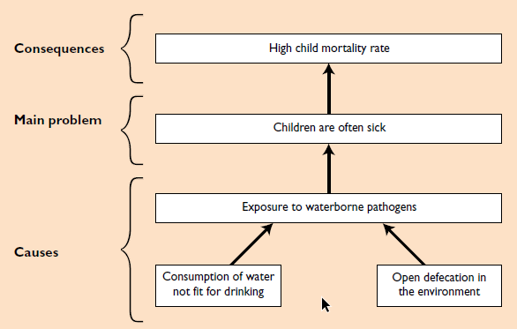

- Example of a problem tree focused on community development

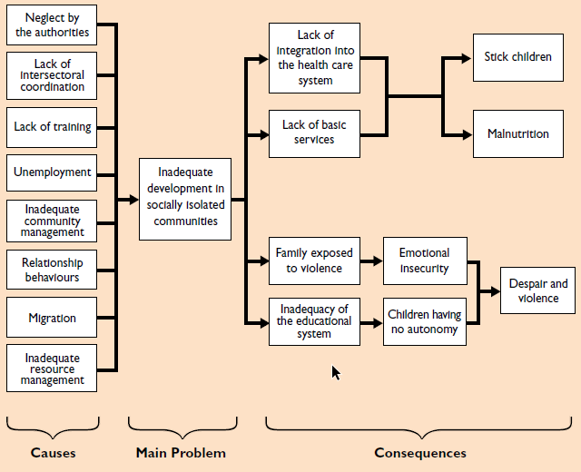
SWOT ANALYSIS MATRIX TEMPLATE

